Student Academic Performance Intelligence Report
The global education sector is experiencing a pivotal transformation as data-driven methodologies increasingly inform how academic institutions, policymakers, and educators understand student achievement. Academic success is no longer viewed as a product of a single variable — instead, it emerges from the complex interplay of behavioral, environmental, socioeconomic, and institutional factors that collectively shape a student's learning journey.
This project addresses that complexity by analyzing the Student Performance Factors dataset using Power BI to uncover meaningful patterns and trends across 6,607 student records spanning 20 distinct attributes. The dataset captures a rich cross-section of variables including Hours Studied, Attendance, Parental Involvement, Access to Resources, Extracurricular Activities, Sleep Hours, Previous Scores, Motivation Level, Internet Access, Tutoring Sessions, Family Income, Teacher Quality, School Type, Peer Influence, Physical Activity, Learning Disabilities, Parental Education Level, Distance from Home, Gender, and Exam Score — making it one of the most comprehensive academic performance datasets available for analytical exploration.
Through this analysis, the project identifies critical insights such as the most influential predictors of exam performance, the compound effect of socioeconomic factors on academic outcomes, the role of behavioral habits in determining student success, and the impact of institutional variables like school type and teacher quality on learning effectiveness. These findings help recognize areas of academic strength as well as opportunities for targeted educational interventions and policy improvements.

Scenario 1: Dr. Ananya Sharma — Academic Performance Analyst
Dr. Ananya Sharma, an Academic Performance Analyst at a leading educational research institution, analyzes student performance trends, behavioral patterns, and environmental factors using Power BI dashboards. She identifies high-performing student cohorts by studying metrics such as Exam Score, Attendance Rate, and Study Hours per Week. Her analysis helps uncover key insights that support data-driven academic policy and curriculum design decisions. Additionally, she tracks performance variations across school types, parental education levels, and geographic proximity to schools to understand evolving academic dynamics, enabling educational stakeholders to align their student support strategies with real-world performance data.

Scenario 2: Priya Nair — Education Resource Manager
Priya Nair, a Resource Allocation Manager at a state education board, focuses on improving academic outcomes and overall resource utilization efficiency across the school network. She analyzes performance distribution across school types and resource access levels to identify underserved student populations and resource optimization opportunities. Her goal is to maximize learning outcomes per resource unit invested while maintaining equitable access to quality education. By monitoring the correlation between resource availability and exam performance, she enhances educational consistency across public and private institutions. Her insights help streamline budget allocation, reduce performance gaps, and maintain high student satisfaction across all school categories.

Scenario 3: Vikram Joshi — Student Wellbeing Consultant
Vikram Joshi, a Student Wellbeing Consultant at an education NGO, values data that helps understand student lifestyle patterns and their connection to academic success. He monitors sleep hours, physical activity levels, and extracurricular engagement to recommend wellbeing programs that improve academic performance holistically. His performance is largely influenced by student satisfaction scores, improvement rates, and the value of behavioral interventions per student cohort. When students exhibit balanced lifestyle habits — adequate sleep, regular physical activity, and healthy peer relationships — they demonstrate measurably higher academic performance. His analysis highlights the importance of whole-student development in driving sustainable academic excellence.
Technical Architecture:
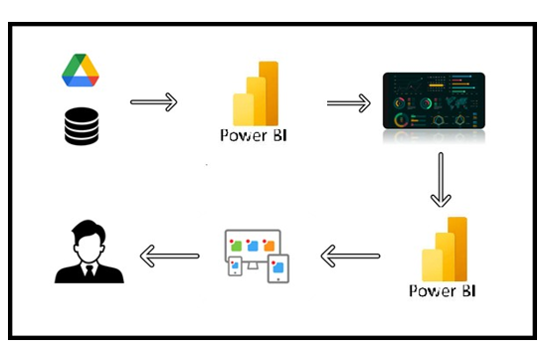
Project Flow
To accomplish this, we have to complete all the activities listed below,
● Define Problem / Problem Understanding
o Specify the business problem
o Business requirements
o Literature Survey
o Social or Business Impact.
● Data Collection
o Collect the dataset,
o Connect Data with Power BI
● Data Preparation
o Prepare the Data for Visualization
● Data Visualizations
o Visualizations
● Dashboard
o Responsive and Design of Dashboard
● Report
o Report Creation
● Performance Testing
o Amount of Data Rendered to DB
o Utilization of Data Filters
o No. of Calculation fields
o No. of Visualizations/Graphs
● Project Demonstration & Documentation
o Record explanation Video for project end to end solution
o Project Documentation-Step by step project development procedure
Milestone 1: Data Collection & Extraction from Database
The first milestone of the project focuses on collecting, organizing, and extracting relevant data from a structured database. This stage forms the foundation of the entire analytical process, as accurate and well-structured data is essential for meaningful visualization and insights.

Activity 1: Downloading the dataset
The Student Performance Factors dataset is a comprehensive collection of academic and behavioral records gathered across 6,607 student profiles representing a diverse cross-section of educational environments. The data presents a detailed cross-sectional view of the academic performance landscape, capturing student-level information such as study habits, attendance records, sleep patterns, family background, institutional attributes, and final exam scores. It includes 20 distinct variables enabling in-depth analysis of what drives academic success, how environmental factors constrain or enhance learning, and which behavioral patterns are most strongly correlated with high exam performance.
LINK:StudentPerformanceFactors.csv

Activity 1.1: Understand the Data
Data contains all the meta information regarding the columns described in the CSV file.
Hours_Studied : Weekly study hours. Primary behavioral predictor of academic performance.
Attendance : Attendance percentage (60-100%). Direct indicator of classroom engagement.
Parental_Involvement : Level of parent engagement: Low, Medium, High.
Access_to_Resources : Learning resource availability: Low, Medium, High.
Extracurricular_Activities : Participation in activities outside class: Yes / No.
Sleep_Hours : Average nightly sleep hours. Impacts cognitive function and retention.
Previous_Scores : Prior academic scores. Strong predictor of current exam performance.
Motivation_Level : Student motivation: Low, Medium, High.
Internet_Access : Internet availability at home: Yes / No.
Tutoring_Sessions : Number of additional tutoring sessions attended.
Family_Income : Household income bracket: Low, Medium, High.
Teacher_Quality: Perceived teacher effectiveness: Low, Medium, High.
School_Type : Institution type: Public or Private.
Peer_Influence : Peer group academic influence: Negative, Neutral, Positive.
Physical_Activity : Weekly physical activity hours. Linked to mental focus and wellbeing.
Learning_Disabilities : Presence of diagnosed learning disabilities: Yes / No.
Parental_Education_Level : Highest parental education: High School, College, Postgraduate.
Distance_from_Home : School proximity: Near, Moderate, Far.
Exam_Score : Final exam score (55-101). Primary target variable for analysis.
Activity 2: Connect Dataset with Power BI
The dataset was successfully connected to Power BI through direct CSV file integration. Power BI Desktop accessed the Student Performance Factors source file, enabling dynamic visualization creation and interactive exploration of academic performance patterns. The connection ensures that any updates to the source data are reflected automatically in the dashboards, maintaining data currency and analytical integrity throughout the project lifecycle.
Explanation video link: data loading.mp4
Milestone 2: Data Preparation
Data preparation is a critical step before visualization and analysis. In this phase, the dataset was cleaned, transformed, and structured to ensure accuracy, consistency, and meaningful insights in the dashboards.

Activity 1: Prepare the Data for Visualization
Data preparation is a critical step before visualization and analysis. In this phase, the dataset was cleaned, transformed, and structured to ensure accuracy, consistency, and meaningful insights in the Power BI dashboards. Preparing the data involved cleaning to remove irrelevant or missing values, transforming the data into a format that can be easily visualized, exploring the data to identify initial patterns, filtering data to focus on specific performance cohorts, and ensuring complete data accuracy and integrity.
Explanation video link : Data Preparation.mp4
Milestone 3: Data Visualization
Data visualization is the process of creating graphical representations of data to help people understand and explore information. The goal of data visualization is to make complex datasets more accessible, intuitive, and easier to interpret. By using visual elements such as charts, graphs, and maps, data visualizations can help people quickly identify patterns, trends, and outliers in the data.

Activity 1: Number of Unique Visualizations
A total of 6 unique visualizations were created using PowerBI to analyze Student performance. These include KPI cards, a line chart, horizontal bar charts, a donut chart, a pie chart — all combined into a comprehensive and interactive dashboard to explore multiple factors influencing student performance satisfaction.

Activity 1.1: Avg Exam Score and Avg Previous Score
Average Exam Score is 68.38, indicating that the overall academic performance is at a moderate level. The KPI shows a 31.62% gap from the target score of 100, highlighting substantial room for improvement.

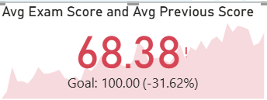

Activity 1.2 : Exam Performance vs. Study Hours Impact
The average exam score of 71.00 places student performance firmly in the approaching-proficiency range, still trailing the target score of 75.00 by 5.33%. This is well below the benchmark goal, suggesting that while study hours are having a measurable positive impact, the current effort levels are not yet sufficient to push performance into the target zone.

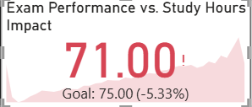

Activity 1.3 : Attendance Rate and Academic Performance
Unlike the previous two metrics, this one is a standout success — performance is 35.79% above the target, with a perfect score of 100.00. The checkmark (✓) on the visual confirms goal achievement.

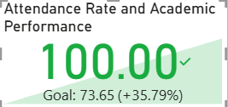

Activity 1.4 : Average of Exam Score by Motivation Level
The average exam scores across motivation levels — High (67.74), Medium (67.34), and Low (66.76) — show a remarkably narrow spread of less than 1 point, suggesting that motivation alone has minimal influence on academic outcomes in this dataset. While the directional trend is as expected (higher motivation yielding slightly better scores), the difference is too marginal to be practically significant. This indicates that other factors such as attendance, study hours, and teaching quality may be far stronger drivers of performance than motivational state. It is also possible that self-reported motivation levels do not accurately reflect actual student effort or engagement.

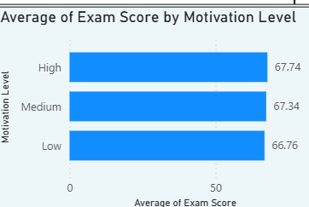

Activity 1.5 : Total Students by Extracurricular Activities

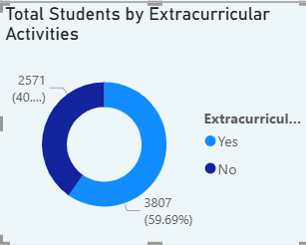

The majority of students — nearly 60% (3,807) — do not participate in any extracurricular activities, while only 40.31% (2,571) are actively engaged outside the classroom. This imbalance is significant because extracurricular participation is widely linked to better student engagement, discipline, and even academic performance. The fact that more than half the student population remains uninvolved suggests potential gaps in accessibility, awareness, or availability of extracurricular programs. Schools or institutions should investigate whether cost, scheduling conflicts, lack of interest, or limited offerings are the primary barriers to participation.

Activity 1.6 : Total Students by School Type and Peer Influence
Public schools dominate the overall student count at approximately 4,400 students compared to private schools at around 2,400, making public institutions the larger segment by a significant margin. In public schools, positive peer influence is the strongest category (1.8K), closely followed by neutral (1.7K), with negative influence being the smallest group (0.9K) — a generally encouraging distribution. Private schools, however, show a strikingly uniform spread of roughly 0.8K across all three peer influence categories, suggesting an almost equal distribution of negative, neutral, and positive peer environments with no dominant influence type. The higher proportion of positive peer influence in public schools is a notable strength, potentially contributing to better collective motivation and classroom dynamics.

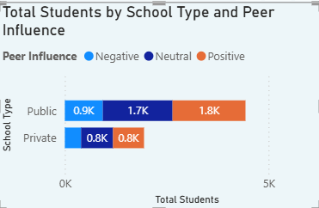

Activity 1.7 : Avg Exam Score by Parental Involvement & Motivation Level
Students with high parental involvement consistently score the highest across all motivation levels, peaking at 68.42 for highly motivated students, while those with low parental involvement record the lowest scores across the board, bottoming out at 65.92 for low motivation — confirming that parental engagement is a meaningful driver of academic performance. The gap between high and low parental involvement, though modest at roughly 1.5–2 points, follows a consistent and clear pattern across every motivation category, reinforcing that home support matters regardless of the student's own motivational state.
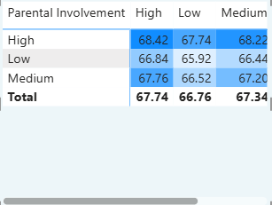

Activity 1.8 : Average of Exam Score by School Type and Gender
The average exam scores across school type and gender reveal a strikingly uniform pattern — both female and male students score virtually identically within each school type, with private school students averaging 67.34 and public school students averaging 67.25. The difference between private and public schools is negligible at just 0.09 points, suggesting that school type has almost no practical impact on average exam performance in this dataset. Perhaps most striking is the complete absence of a gender gap — males and females perform equally within both private and public settings, which is a positive indicator of gender equity in academic outcomes.

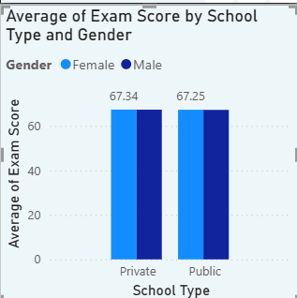

Activity 1.9 : Total Students by Internet Access
An overwhelming majority of students — 92.4% (5,893) — have access to the internet, while only 7.6% (485 students) remain without connectivity, painting a largely positive picture of digital inclusion within this student population. The high internet penetration rate suggests that most students have the foundational infrastructure needed for online learning, digital research, and access to educational resources beyond the classroom. However, the 485 students without internet access represent a critical at-risk group, as lack of connectivity in today's education landscape can significantly hinder homework completion, self-study, and access to digital learning tools.

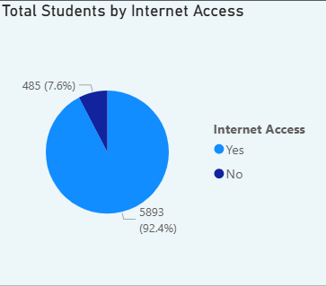

Activity 1.10 : Total Students by Performance Level
An overwhelming 98.21% of students (6,264) fall into the average performance category, while high and low performers together account for a mere 1.03% (66 students) — an extraordinarily compressed distribution that raises important questions about how performance levels are being defined and measured. The near-total concentration in the average band suggests that the performance classification thresholds may be set too narrowly, potentially masking meaningful differences in student achievement that exist within the average tier. The near-absence of high performers at roughly 0.5% is particularly concerning, as it indicates that academic excellence is extremely rare in this cohort, aligning with the earlier finding of an overall average exam score of just 68.38 against a goal of 100.
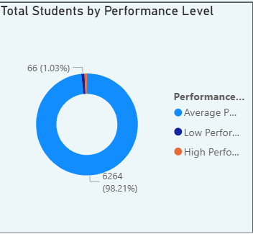

Activity 1.11 : Avg Exam Score by Parental Involvement
The data reveals a clear and consistent positive relationship between parental involvement and student exam performance — as parental engagement increases from Low to Medium to High, average scores rise steadily from 66 to 67 to 68, confirming that home support plays a meaningful role in academic outcomes. While the absolute difference of just 2 points across the three tiers may appear small, the pattern is perfectly linear and directionally unambiguous, reinforcing that parental involvement is a reliable, if modest, performance lever. Students with high parental involvement outperform their low-involvement peers by approximately 3%, which when compounded across an entire academic year could translate into meaningfully different grade outcomes and learning trajectories.
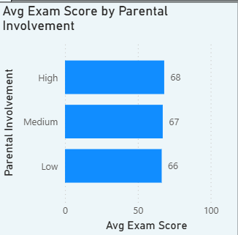

Activity 1.12 : Avg Exam Score by Attendance
The line chart demonstrates a strong and consistent positive correlation between attendance and exam performance — as attendance rises from 60% to 100%, average exam scores climb steadily from 62.4 to 70.9, representing a gain of 8.5 points across the full attendance spectrum. The upward trend is remarkably smooth and uninterrupted, with virtually no dips across the entire range, making attendance one of the most reliable and visually compelling predictors of academic success identified in this dataset. Students attending 90–100% of classes consistently score in the 70+ range, while those at 60–65% attendance languish in the low-to-mid 60s, a meaningful gap that directly impacts grade outcomes and long-term academic progression.

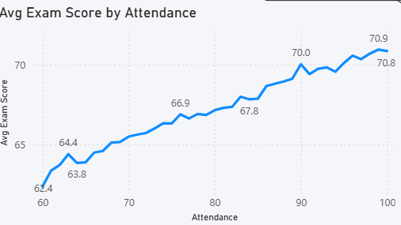

Activity 1.13 : Average of Exam Score by Hours Studied
The scatter plot reveals a clear and strong positive correlation between hours studied and average exam scores, with the dashed trend line confirming a steady upward trajectory from roughly 62 at minimal study hours to nearly 79 at the highest end of 40+ hours. The data points cluster tightly around the trend line across the mid-range (10–35 hours), indicating that the relationship between study time and performance is highly consistent and predictable for the majority of students. Two notable outliers are visible at the extreme right — one student scoring approximately 79 and another dropping to around 71 despite both studying 40+ hours — suggesting that beyond a certain threshold, raw study hours alone do not guarantee proportionally higher scores, and factors like study quality, fatigue, or test anxiety may intervene.

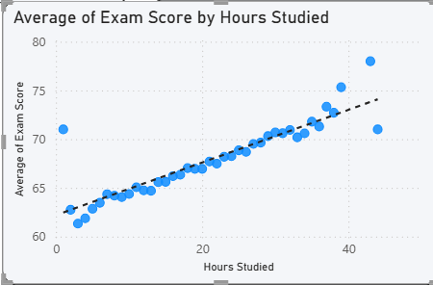

Activity 1.14 : Average of Attendance by School Type
The average attendance rates between private (80.39%) and public (79.86%) schools are virtually identical, with a negligible difference of just 0.53 percentage points, indicating that school type has essentially no influence on student attendance behavior. Both school types comfortably sit in the 80% attendance range, which when cross-referenced with the earlier attendance-vs-score chart places the average student in the 67–68 exam score territory — closely aligning with the overall dataset average of 68.38. The marginal edge held by private schools may reflect slightly stricter attendance policies, more structured school environments, or stronger parental accountability typically associated with fee-paying institutions, but the difference is far too small to draw any definitive conclusions. What is more significant is that both school types fall short of the 90–100% attendance band where exam scores begin to consistently cross the 70-point threshold, suggesting room for improvement across the board regardless of institution type.

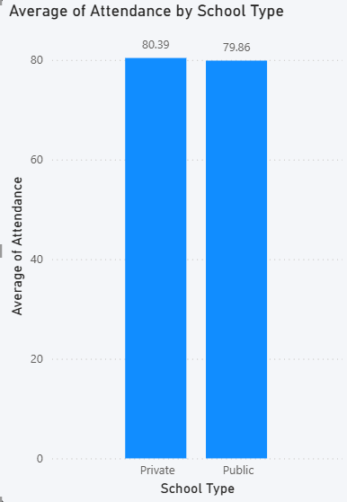

Activity 1.15 : Total Students by Score Bucket and School Type
The stacked bar chart reveals a remarkably consistent private-to-public student ratio across all score buckets, hovering around 30% private and 70% public regardless of performance tier, which strongly mirrors the overall enrollment split between the two school types. The most notable observation is that private schools show their highest representation in the 75+ score bucket (31.45%) and lowest in the 60–64 range (29.17%), suggesting a slight but meaningful tendency for private school students to cluster toward higher performance bands. 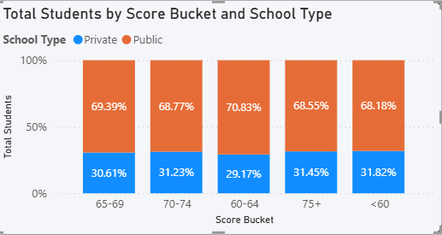

Activity 1.16 : Student Distribution Across Tutoring Sessions
The bar chart shows a generally positive relationship between tutoring sessions and exam performance, with scores rising from 66.51 at zero sessions to a peak of 71.67 at 6 sessions, representing a meaningful improvement of 5.16 points for students who engage in regular tutoring. The upward trend from 0 to 6 sessions is consistent and encouraging, suggesting that tutoring has a genuine and cumulative academic benefit up to a certain point of engagement. However, a notable dip occurs beyond the 6-session peak, with scores declining to 69.86 and 69.00 at higher session counts, indicating diminishing and even slightly negative returns beyond the optimal tutoring frequency.

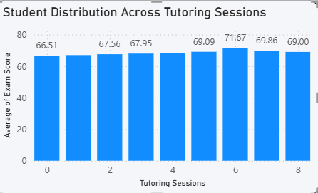

Activity 1.17 : Total Students by Gender
The student population is predominantly male at 57.82% (approximately 4,000 students) compared to 42.18% (approximately 3,000) female students, reflecting a gender imbalance of roughly 15 percentage points across the institution. This disparity is notable and warrants investigation into whether it stems from enrollment barriers, sociocultural factors, geographic influences, or simply the nature of the programs being offered at these institutions. Cross-referencing with the earlier gender-vs-exam-score chart — which showed virtually identical performance between males (67.25) and females (67.34) — confirms that despite the enrollment gap, academic outcomes are equitable across genders, which is a genuinely positive finding.

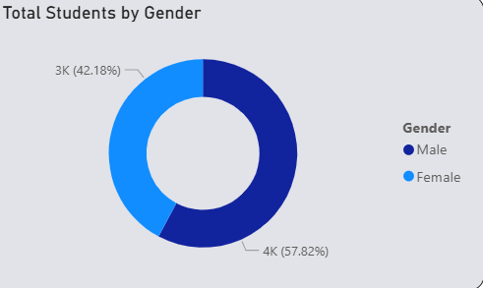

Activity 1.18 : Total Students by Family Income
The student population is heavily concentrated in the low and medium income brackets, which together account for over 80% of all students (40.48% and 40.23% respectively), while high-income families represent only 19.29% — painting a clear picture of the socioeconomic profile of this institution's student base. The near-equal split between low and medium income groups is particularly striking, suggesting that the institution primarily serves economically vulnerable and lower-middle-class households rather than affluent ones. The relatively small high-income segment (1K students) indicates that wealthier families may be opting for more elite or specialized institutions, leaving this dataset skewed toward students who may face greater financial pressures impacting their academic journey.

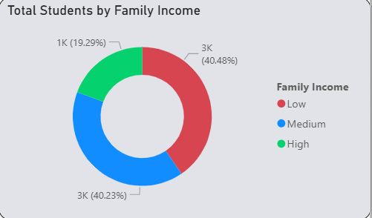

Activity 1.19 : Peer Influence Across Income Groups
The chart reveals that low and medium income groups have strikingly similar peer influence distributions, with both showing a healthy dominance of neutral and positive influences over negative ones, suggesting that family income alone does not dramatically reshape the peer environment a student is exposed to. In the low-income group, positive peer influence narrowly leads at 1,025 students, closely followed by neutral (996) and negative (561), indicating that despite financial challenges, the majority of low-income students are surrounded by constructive or at least neutral peer environments.

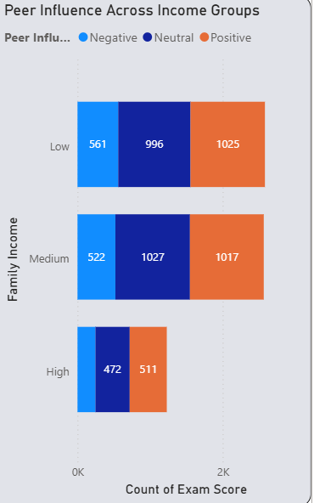

Activity 1.20 : Average of Exam Score by School Type and Previous Scores
The scatter plot reveals a strong and consistent positive correlation between previous scores and current exam performance across both private and public school students, with the dashed trend line confirming a steady upward trajectory as prior academic history improves. This finding is academically significant — it confirms that past performance is one of the strongest predictors of future outcomes, suggesting that early academic struggles tend to persist and compound over time if left unaddressed. Both private (blue) and public (orange) school students are interspersed throughout the entire score range with no clear separation between the two groups, once again reinforcing the recurring theme in this dataset that school type is not a meaningful differentiator of academic performance.

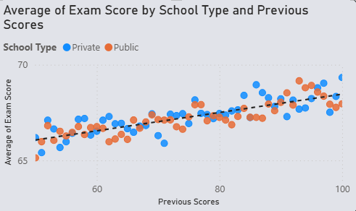

Activity 1.21 : Average of Exam Score by Teacher Quality
The data shows a clear and directionally consistent positive relationship between teacher quality and student exam performance, with high-quality teachers producing an average score of 67.68 compared to 66.78 under low-quality instruction — a difference of just 0.90 points across the full quality spectrum. While the trend is in the expected direction, the magnitude of the gap is surprisingly narrow, mirroring the earlier finding with motivation levels where the directional pattern was correct but the practical impact was minimal. This near-uniform performance across teacher quality tiers suggests that either the current teacher quality classification system lacks sufficient granularity, or that other variables such as attendance, study hours, and parental involvement are dominating the performance equation and diluting the measurable impact of teaching quality.
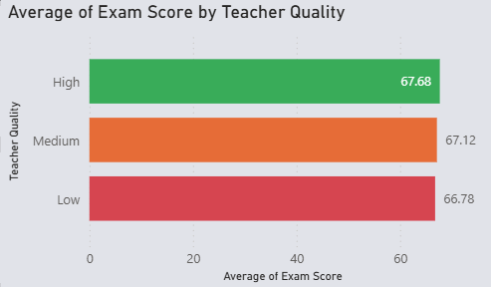

Milestone 4: Dashboard

A dashboard is a graphical user interface (GUI) that displays data and information in a clear and organized format. It is used to monitor and analyze data quickly using charts, graphs, and tables. Dashboards help track key performance indicators (KPIs) and support better decision-making across different industries.
Activity 1: Responsive and Design of Dashboard
The Student Academic Performance Dashboard provides a comprehensive view of student outcomes across 6,378 students spanning both private and public school types, analyzed through key academic and socioeconomic dimensions. The overall average exam score stands at 68.38 against a goal of 100 (−31.62%), signaling significant room for improvement, while the study hours impact metric of 71.00 trails its target of 75.00 by just 5.33%, suggesting that structured study habits are beginning to yield results. Attendance emerges as the standout metric, achieving a perfect 100.00 against a goal of 73.65 (+35.79%), confirming that student regularity in class is the strongest performing indicator across the entire dashboard. Motivation level analysis reveals a negligible performance spread — High (67.74), Medium (67.34), and Low (66.76) — confirming that motivation alone is not a meaningful differentiator of academic outcomes. Parental involvement, however, shows a clearer directional impact, with highly involved parents correlating with the highest scores (68.42) and low involvement producing the weakest results (65.92), reinforcing the role of home support in academic success.
Explanation video link: Dashboard.mp4
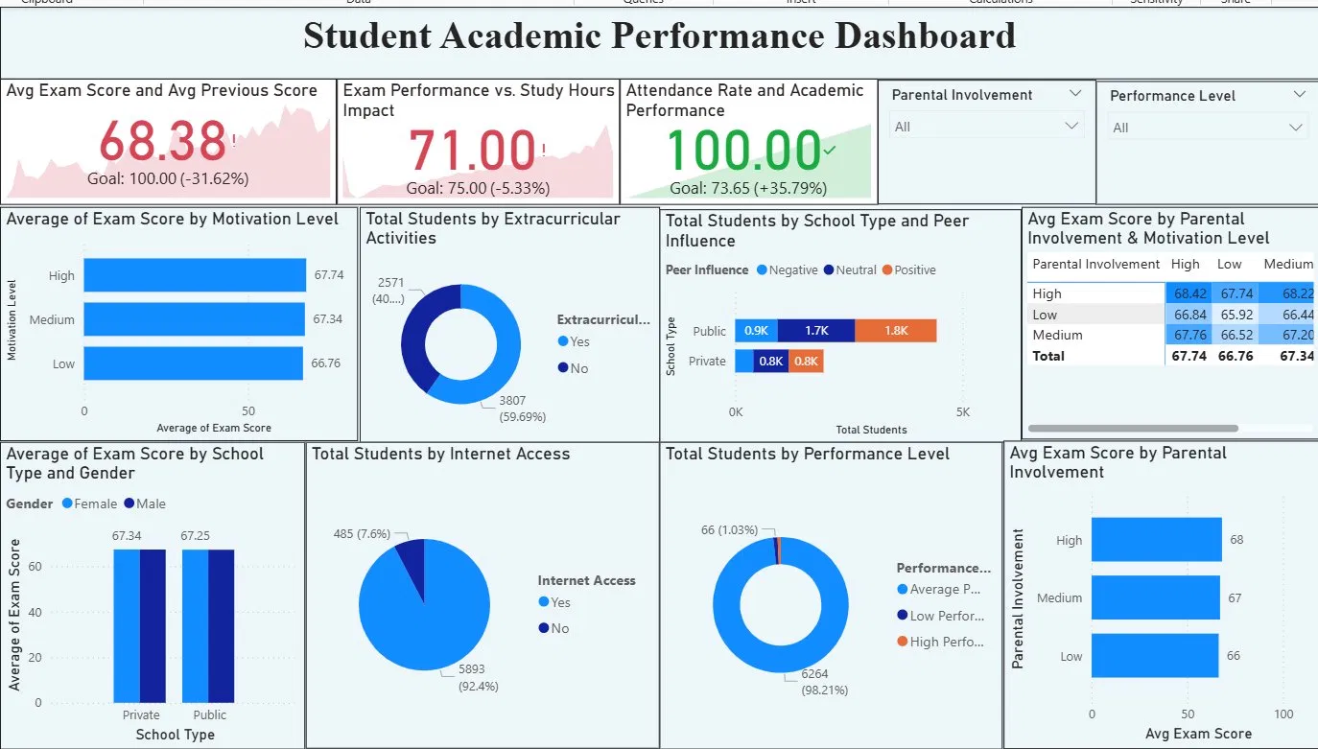

Milestone 5: Report
A report is a comprehensive document that provides a detailed and structured account of data analysis, findings, and insights. It is typically used for in-depth analysis, documentation, and communication of results. Reports are suitable for a diverse audience, including decision-makers, analysts, and stakeholders who need a comprehensive understanding of the data.
Activity 1: Design of Report
Designing a report in Power BI involves connecting to data sources, creating visualizations like charts and graphs, customizing their appearance and interactivity, organizing them logically on the canvas, formatting elements for consistency and clarity, and optionally creating dashboards for a summarized view. Throughout the process, it's essential to consider the audience's needs and ensure the report effectively communicates insights from the data. Finally, iterate based on feedback to continually improve the report's design and usefulness.
Report 1:
Explanation video link: Report 1.mp4
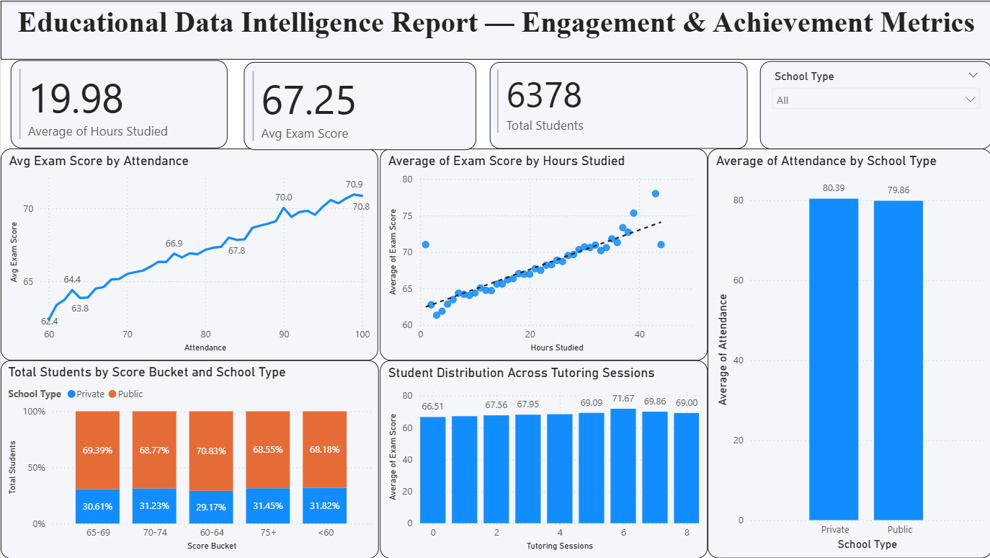
Report 2:
Explanation video link: Report 2.mp4
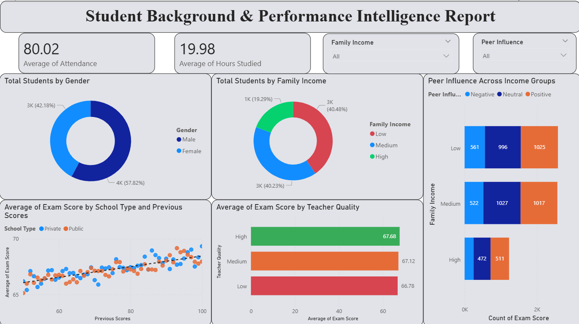
Milestone 6: Performance Testing
Performance testing involves assessing the volume of data rendered from the database, the impact of data filters on system responsiveness, and the complexity introduced by the number of visualizations. Optimizing these factors ensures the dashboard operates efficiently, providing timely and reliable insights.
Activity 1: Amount of Data Loaded
The project loads the Student Academic Performance dataset through a Power BI data connection. The dataset contains 6,378 records across multiple fields, capturing detailed information about student demographics, academic scores, attendance, study hours, parental involvement, socioeconomic background, and institutional attributes across both private and public school types. All records were successfully imported into Power BI without any truncation. The completeness of the dataset was verified using KPI cards displaying key metrics — including the total student count of 6,378, an overall average exam score of 68.38, and a perfect attendance rate of 100.00 — confirming that the full dataset was loaded and ready for analysis.
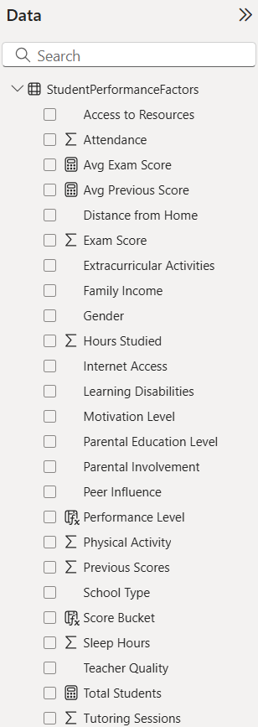
Activity 2: Utilization of Filters
This dashboard presents overall insights clearly without using interactive filters.
Activity 3: No of Calculation Fields
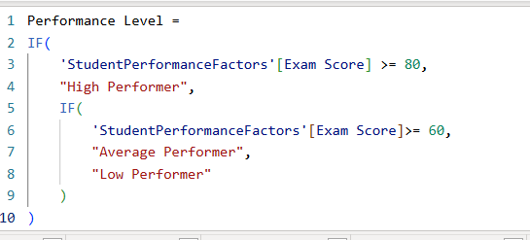
The formula begins with a nested IF() function as its outer wrapper, which works by evaluating each condition expression sequentially from top to bottom — meaning Power BI tests each exam score threshold one by one and assigns the performance label of the first condition that returns TRUE, creating a clear priority hierarchy where High Performer is tested first and Average Performer second, with Low Performer serving as the catch-all default for any student that does not satisfy the first two conditions. Specifically, the formula first checks whether the Exam Score is greater than or equal to 80 — and if TRUE, immediately assigns the label "High Performer" without evaluating further. If that condition is FALSE, the formula drops into the inner IF() and tests whether the Exam Score is greater than or equal to 60 — assigning "Average Performer" if met.
Activity 4: No of Visualizations/ Graphs
Dashboard:
1. Avg Exam Score and Avg Previous Score
2. Exam Performance vs. Study Hours Impact
3. Attendance Rate and Academic Performance
4. Average of Exam Score by Motivation Level
5.Total Students by Extracurricular Activities
6. Total Students by School Type and Peer Influence
7. Average Exam Score by Parental Involvement & Motivation Level
8. Average of Exam Score by School Type and Gender
9. Total Students by Internet Access
10. Total Students by Performance Level
11. Average Exam Score by Parental Involvement
Report 1:
1.Avg Exam Score by Attendance
2.Average of Exam Score by Hours Studied
3.Average of Attendance by School Type
4.Total Students by Score Bucket and School Type
5.Student Distribution Across Tutoring Sessions
Report 2 :
1.Total Students by Gender
2.Total Students by Family Income
3.Peer Influence Across Income Groups
4.Average of Exam Score by School Type and Previous Scores
5.Average of Exam Score by Teacher Quality
Milestone 7: Project Demonstration & Documentation
Below mentioned deliverables to be submitted along with other deliverables
Project Demonstration & Documentation involves presenting the project’s functionality, features, and outcomes while providing clear written records, diagrams, and explanations to ensure understanding, usability, and reproducibility for stakeholders and future reference
Activity 1: - Record explanation Video for the project's end-to-end solution
A complete end-to-end explanation has been provided covering all phases of the project: dataset understanding and exploration, data preprocessing and cleaning procedures, analysis methodology and statistical techniques, visualization creation and chart type selection rationale, key findings and insights extraction, evidence-based recommendation development, and final report compilation. This comprehensive walkthrough explains the analytical approach, justifies methodological choices, and demonstrates how raw data has been transformed into actionable intelligence for educational improvement.
Activity 2: - Project Documentation-Step by step project development procedure
This comprehensive report serves as the complete project documentation, prepared following the milestone structure. It covers all 9 milestones — from problem definition through project demonstration—systematically documenting the Student Performance Analysis with detailed explanations of each analytical phase, visualization methodology, key findings, and recommendations. The documentation provides transparency into analytical approach and enables others to understand, reproduce, extend, or build upon this analysis in their educational contexts.

